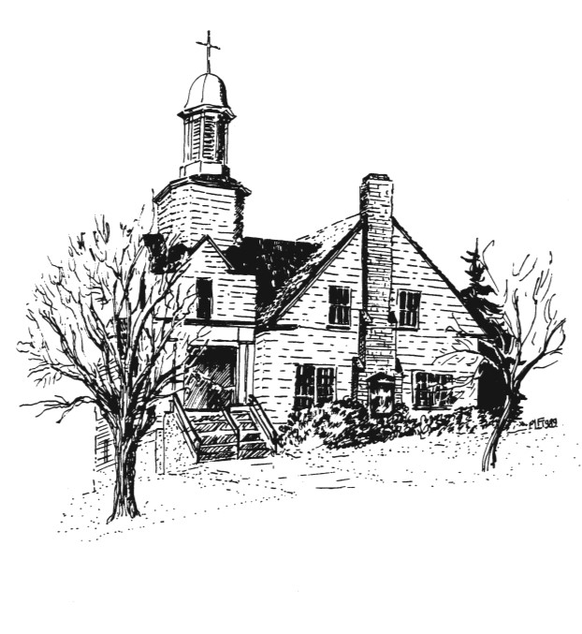
Music Team Schedule
Jan – Apr 2019

Leader Piano A/V
Dec 23 Deann Hannah David, Naomi (Christmas)
Dec 30 Georgia Karen Harry, Aline (New Years)
Jan 06 Rick Karen Harry, Hilary
Jan 13 Deann Karen Harry, Naomi
Jan 20 Georgia Karen Harry, Aline
Jan 27 Rob * David, Hilary
Feb 03 Rick Hannah *, Naomi
Feb 10 Deann * Harry, Hilary
Feb 17 Georgia Hannah Harry, Aline
Feb 24 Rob * David, Naomi
Mar 03 Deann * *, Aline
Mar 10 Rick * Harry, Naomi (Womens Retreat)
(PST -> PDT)
Mar 17 Rob Hannah David, Hilary
Mar 24 Georgia * Harry, Aline
Mar 31 Rick * *, Hilary
Apr 07 Deann Hannah David, Naomi
Apr 14 Georgia * Harry, Aline
Apr 21 Rob * Harry, Hilary (Easter)
Apr 28 Rick * *, Naomi
May 05 Deann Hannah *, Aline

* no assignment as yet, TBD

Current exclusions:
Karen: Jan 27 – Apr 28

Dec 14, Jan 17

