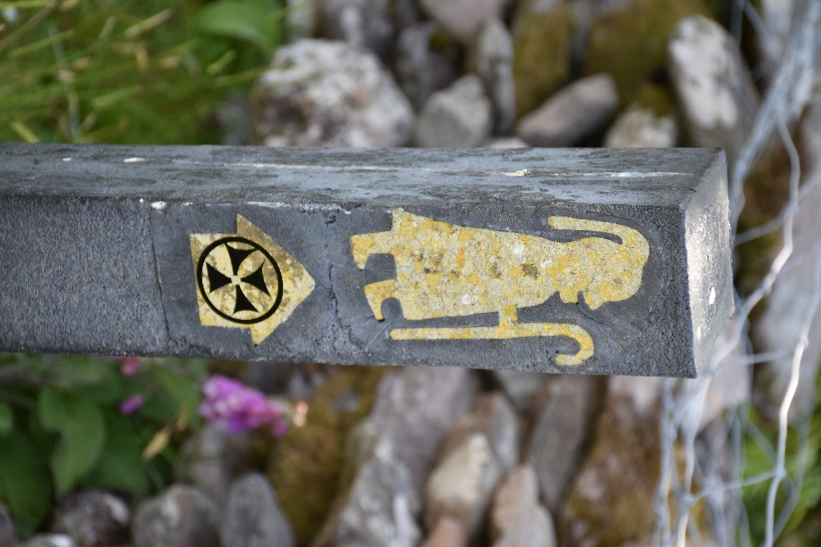
While in Ireland in the summer of 2019, we found a number of these symbols on posts. They are official markers for an historical pilgrimage path. A pilgrimage is a journey to a site of religious significance. The journey itself becomes a “spiritual exercise” in which one seeks (and expects) to encounter God along the way. In Ireland they are also called “penitential paths” - ways for repentance. For hundreds of years, Christians have been breaking their routines to walk through the wilderness; think of a pilgrimage as a “walking retreat.”
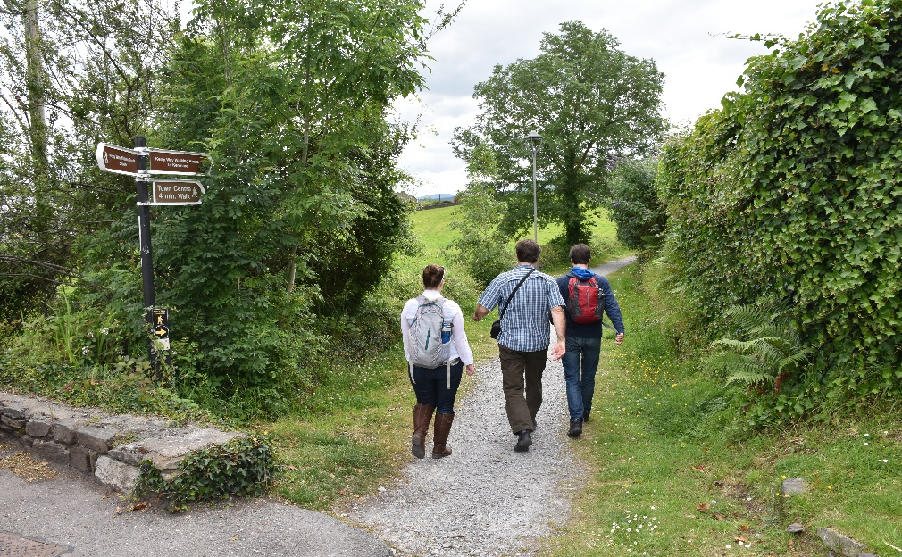
Our family chose to walk along some of these ancient paths several times during our trip.

These walks gave opportunity to learn about our spiritual heritage, to connect to “the great cloud of witnesses” of our faith, an even encounter God.
The markers help pilgrims “stay on the way” – which sometimes meant walking through someone’s private field full of sheep! In Ireland the “right of way” of pilgrims is protected even across private land and so sometimes meant crossing fence (or wall) lines (see below).

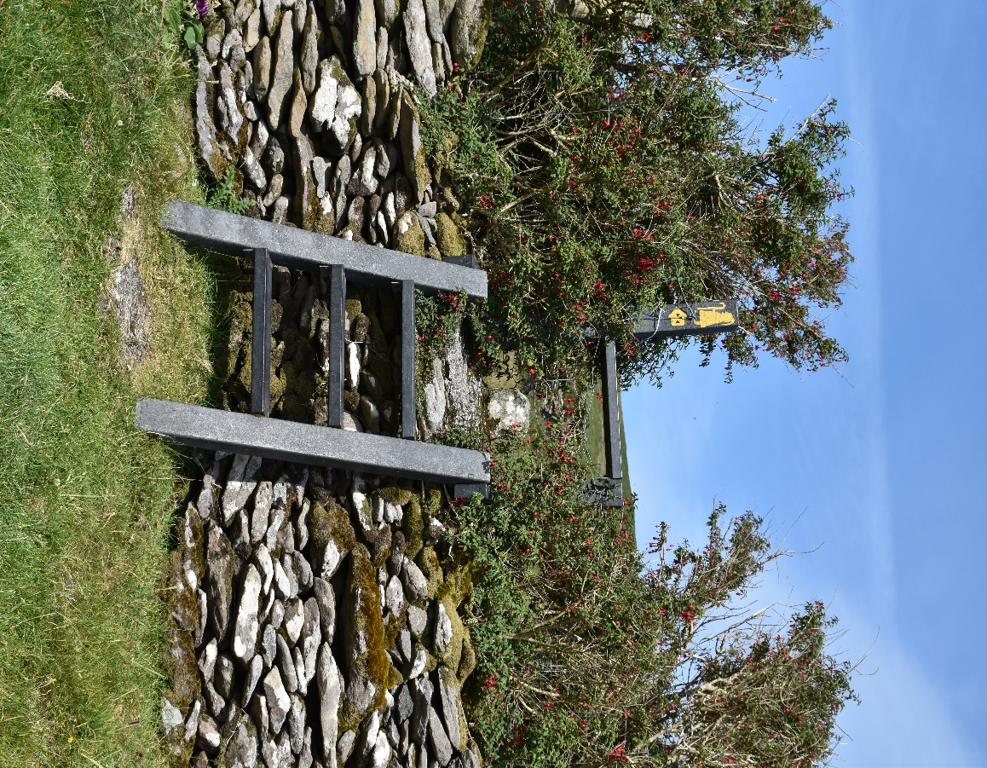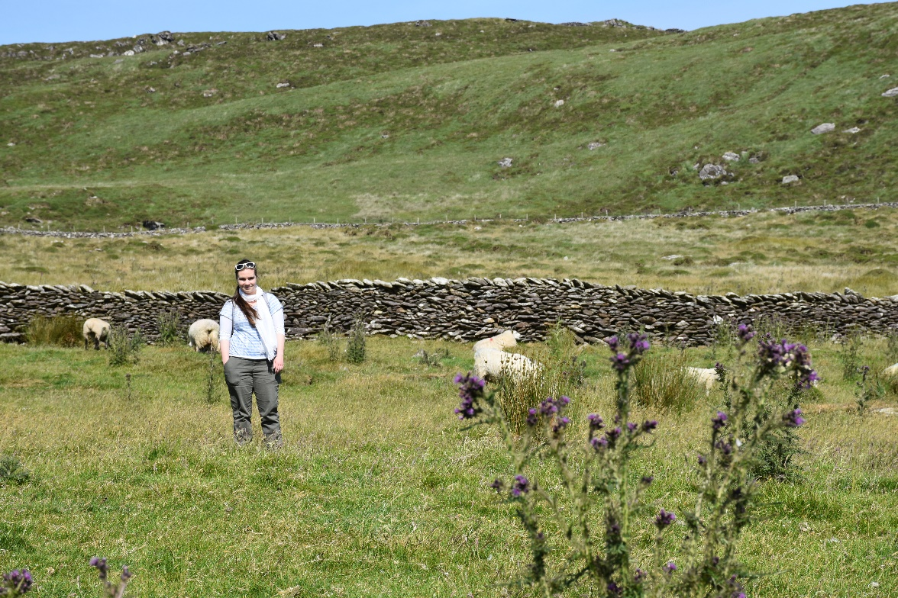
Our “journey” over Lent this year is a forty-day journey between Ash Wednesday and Resurrection Sunday (not including the other Sundays). In 441AD, Patrick is said to have spent 40 days atop Croagh Patrick (a mountain now named after him) praying and fasting before confronting the kings of Ireland. I believe that he was following the model of our Lord, Jesus Christ, and his forty days in the wilderness. It is possible that Patrick wrote or prayed something like his Lorica during this period of preparation. We had the privilege of visiting Croagh Patrick: 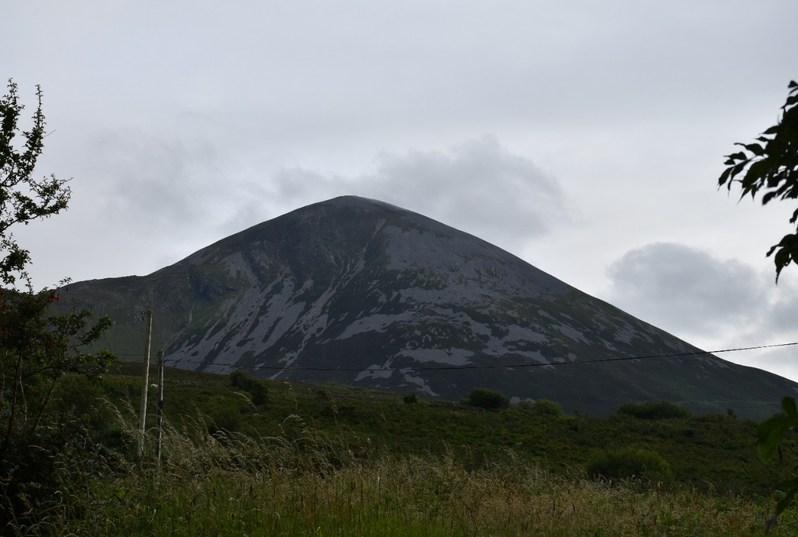
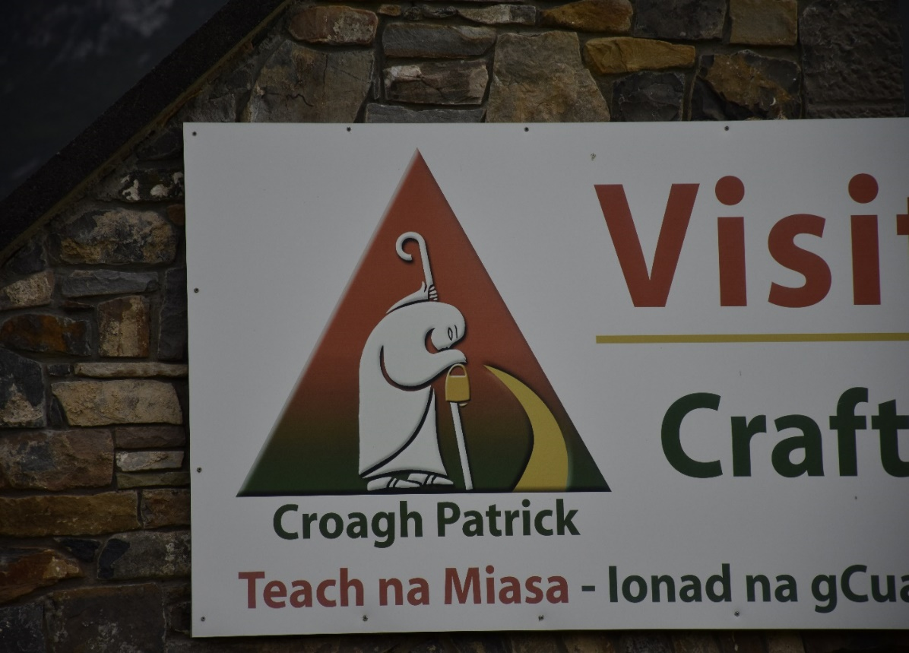
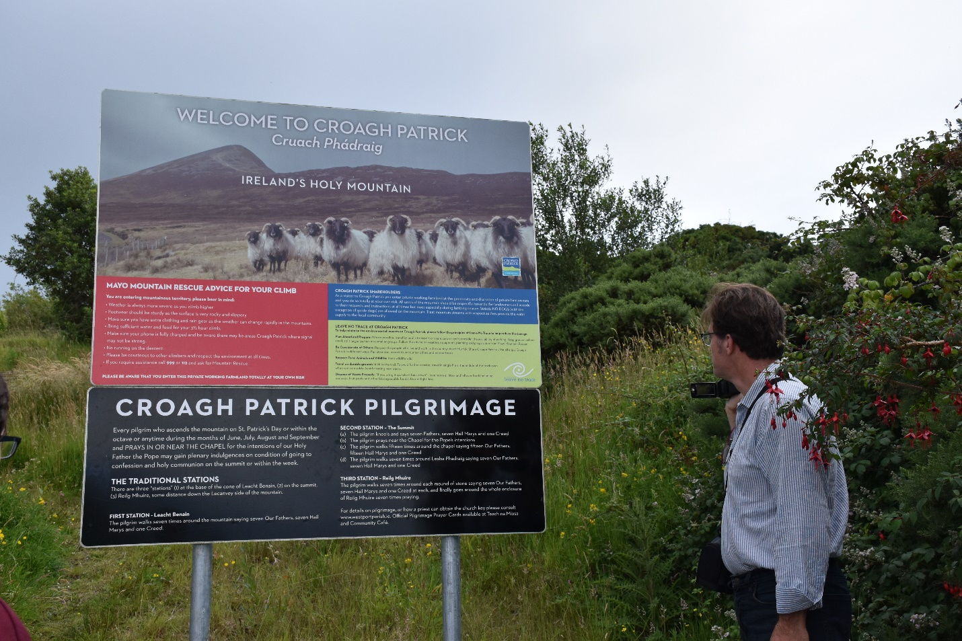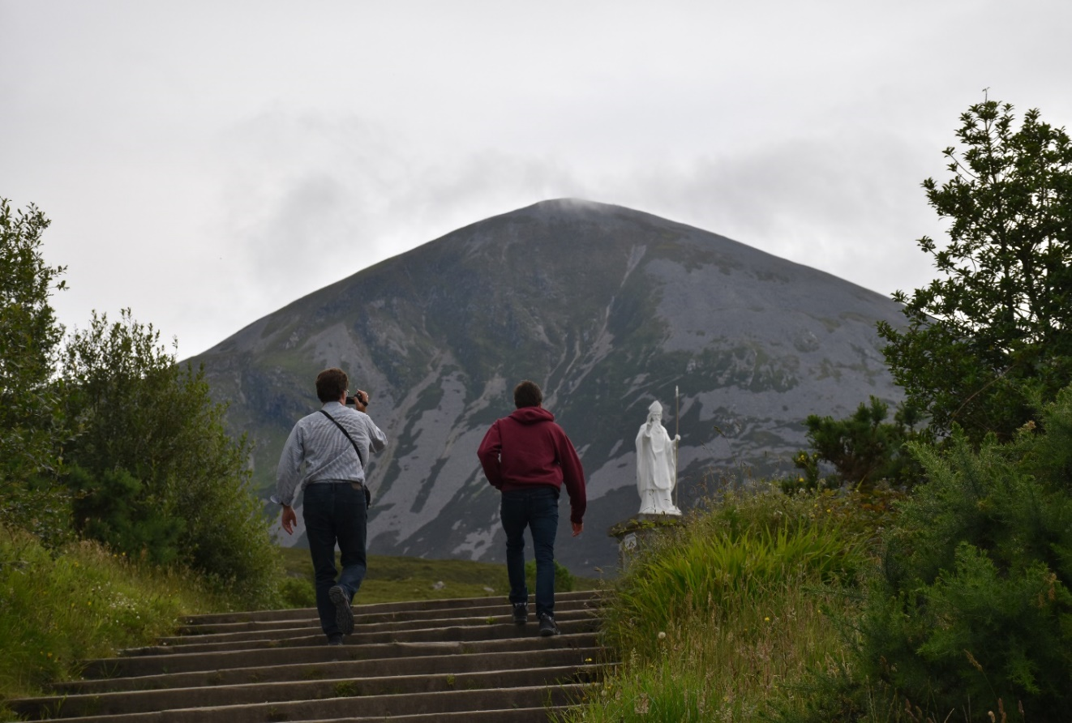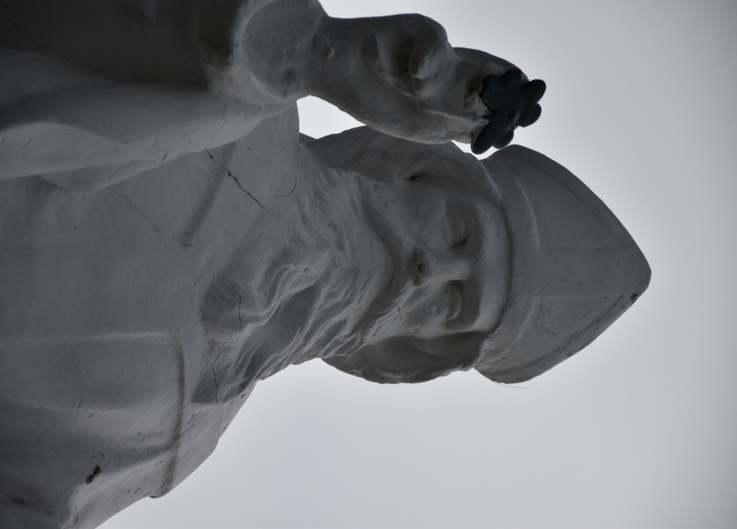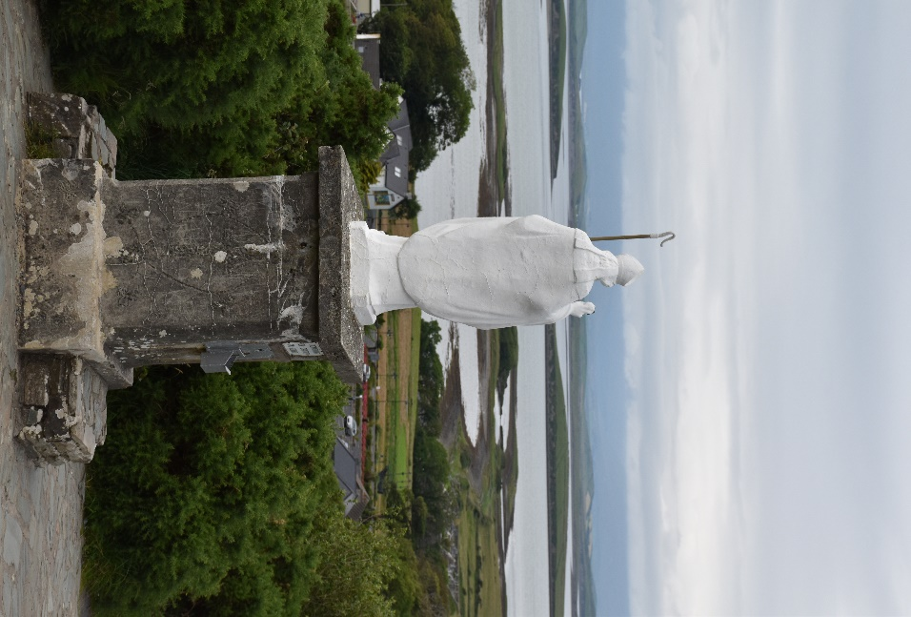
Pretty cool view from the statue of Patrick! – that’s the Atlantic Ocean. We are on the West Coast of Ireland not far from a town called Westport.
Join us as we Pilgrimage through the Lorica of St. Patrick with images of the land of St. Patrick: “I Arise Today…”

