The story of Christianity in Ireland is much bigger than Patrick. Christianity had arrived in Ireland before Patrick and a Celtic noble from Gaul (modern day France) named Palladius was the first appointed bishop of Christians in Ireland in 431AD.
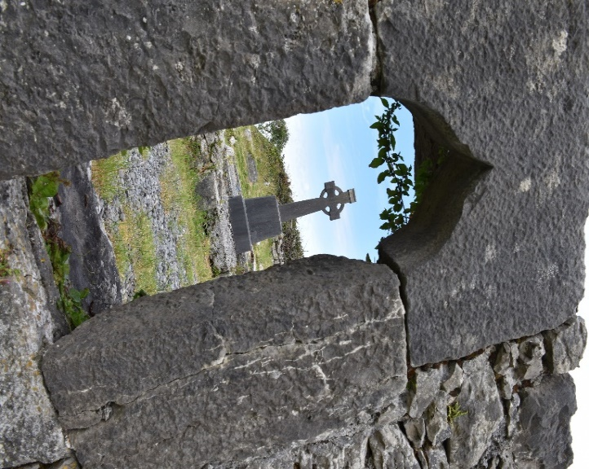
Our best information is that Patrick’s ministry was focused the north (though he is said to have preached all over the island), but others took the Gospel ministry to the south.
On the island of Inis Mor (Inishmore) the largest of the three Aran Islands on the west coast of Ireland, two monastic training centers were built in the 6th century: the monastery at Killeaney by St. Enda) and the Na Seacht dTeampaill, (The Seven Churches) by St Brecan (shown in pictures). Inis Mor was a pilgrimage site and most of the great saints of Ireland (more on them later) are said to have spent time here.

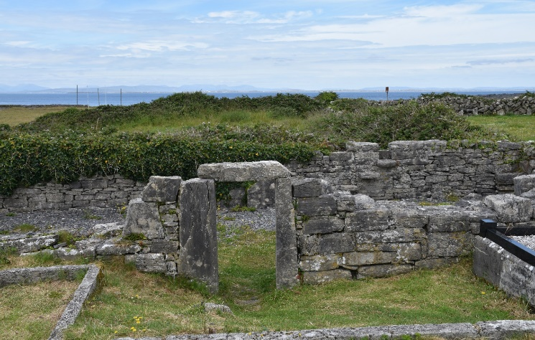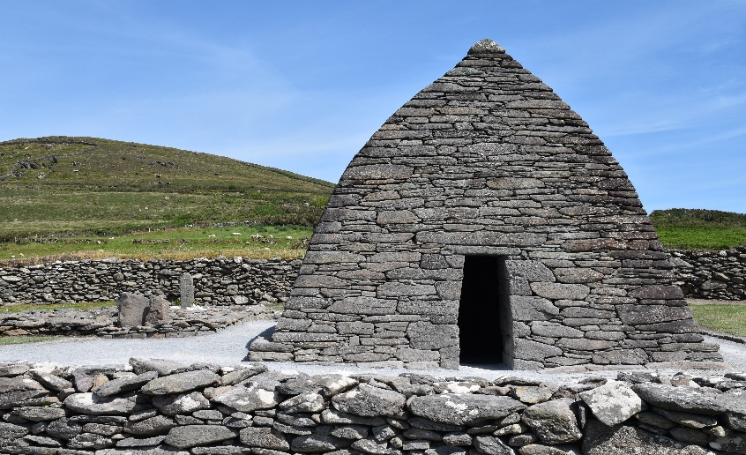
St. Columba (who would found Iona) called Inis Mor the “Rome of Pilgrims” as so many people, including Columba himself, traveled to the island for spiritual retreat and learning.
This spread of faith is quite remarkable. Patrick died sometime in the late 400’s. Enda died about 530 AD. Enda was an Irish prince and soldier, who was converted through the ministry of his sister, already a abbess, gave up politics to build a community for spiritual growth. Hsitorical records suggest Enda was old when he died, so he likely was alive (though quite young) during some part of Patrick’s ministry. This means by the “second generation” – in less than 50 years – Christianity had transformed Ireland.

